Quantitative Analysis of the 'Toss Advantage' in the Indian Premier League (IPL)
In professional cricket, the coin toss is often perceived as a critical determinant of match outcomes. This study investigates the validity of the "Toss Advantage" hypothesis using a large-scale longitudinal dataset from the Indian Premier League (IPL). By analyzing 1,000 matches, the research aims to move beyond evidence to determine if winning the toss provides a statistically significant benefit or if match outcomes are governed by more complex variables such as venue-specific environmental conditions and tactical decision-making.
METHODOLOGY
- Data Acquisition: A raw dataset consisting of 1,000 JSON files was extracted and structured using Microsoft Excel and Power Query.
- Data Cleaning: The dataset was filtered to isolate "info" metadata from ball-by-ball records, ensuring high-speed processing and data accuracy.
- Statistical Controls: To prevent "small-sample bias," a frequency filter was implemented. Only venues with a minimum of 10 matches were included in the final venue-specific analysis to ensure that the results were not skewed by statistical outliers.
LEAGUE-WIDE FINDINGS
- Total Average Toss Win Rate: 50.7%.
- Conclusion: On a league-wide basis, winning the toss provides a negligible advantage of only 0.7% above a 50/50 split, suggesting that the IPL is a highly competitive and balanced league.
TACTICAL DECISION ANALYSIS (BATTING VS. FIELDING)
While the coin flip itself is neutral, the decision made by the winning captain introduces a significant performance gap:
- Fielding First: Yields a win rate of 53.1%.
- Batting First: Yields a win rate of 46.3%.
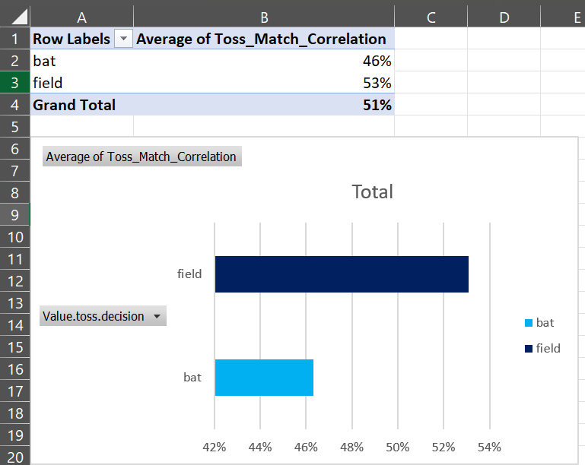
- Conculsion: There is a clear 6.8% "Chasing Bias" in the IPL. This suggests that captains who win the toss and choose to bowl first are statistically more likely to secure a victory.

ENVIRONMENTAL VOLATILITY
- Standard Deviation : 0.098.
- Interpretation: A high standard deviation of nearly 10% proves that the impact of the toss varies wildly by location.
- Venue Variations: Specific venues like Eden Gardens (34.7%) show a negative correlation with the toss, whereas others show significantly higher correlations. This indicates that factors such as the "Dew Factor" and pitch deterioration are the true drivers of these results.

CONCLUSION: DEBUNKING THE "TOSS MYTH"
The most significant finding of this study is that the "Toss Advantage" in the IPL is largely a psychological artifact rather than a statistical reality. While traditional cricket commentary places immense weight on the coin flip, a 1,000-match analysis reveals a negligible league-wide win correlation of just 50.7%.
However, the data exposes a critical Tactical Inefficiency:
- The Chasing Edge: Teams that win the toss and field first have a 53.1%-win rate, while those choosing to bat first drop to 46.3%. This nearly 7% gap suggests that the "advantage" is not the toss itself, but the decision to chase.
- The Venue Variance: The high Standard Deviation of 0.098 proves that the toss is a "Location-Dependent Variable". At certain stadiums like Eden Gardens (34.8% toss-win correlation), winning the toss is actually a statistical disadvantage, likely due to shifting pitch dynamics that captains fail to predict.
Ultimately, this study proves that team strategy and environmental adaptation far outweigh the luck of a coin flip. For the data analyst, the lesson is clear: never trust the "average" when the standard deviation tells a much more volatile story.

